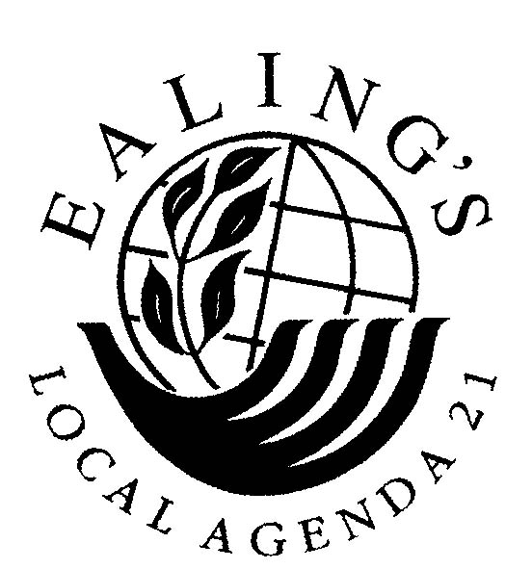
Ealing’s Local Agenda 21 Front Gardens Project
The Ealing front garden hard surfacing epidemic

In 2005, many volunteers helped Ealing’s LA21 Front Gardens Project conduct the first ever survey of the extent of hard surfacing of front gardens in the borough. This found:
- There are 74,300 front gardens in the London Borough of Ealing.
- A quarter of these are completely (100%) covered in hard surfacing.
- Six out of ten have 70% or more of their area hard surfaced.
- Only 17% have ‘traditional’ 20% or less hard surfaced – just a path to the front door and perhaps a narrow strip round the front of the house.
- Across the whole borough, the average front garden has 68% of its area covered with hard surfacing.

Why is this happening? Two main reasons:
1. Some people see hard surfacing as tidy, low-maintenance, even stylish.
2. Parking and the “Domino Effect”: to park in a front garden, residents require a Council-approved pavement crossover (kerb drop). This effectively prevents anyone else parking on that stretch of road. So there’s less parking space in the road. So more residents apply for crossovers. So there’s even less parking space. In a few years all the front gardens in a road can become car parks (see graph).

Unlike Ealing Council, the Royal Borough of Kensington & Chelsea uses the Highways Act 1980 to prevent on-road parking being removed by crossovers, and refuses most crossover applications.

Hints and tips for keeping your front garden alive ➔ ➔ ➔ ➔ ➔ ➔ Page 2
39 problems caused by hard surfacing front gardens ➔ ➔ ➔ Pages 3 & 4
Three golden rules for front gardens
1. Keep the amount of hard surfacing to a minimum
Even if the front garden is used for parking, two tracks for the car’s wheels plus a path is all the hard surfacing needed. This will also be less expensive than extensive hard surfacing.
2. Use permeable hard surfacing materials
Choose a surface that lets water through, such as gravel, grills, small slabs, bricks or matrix pavers, and ensure that the hardcore layer below is also permeable. This allows rain water to drain naturally through the soil.
3. Have plants which don’t need much care and attention
There are many shrubs, perennial flowers, self-seeding annuals and small trees which don’t need much looking after and, in combination, look attractive all year round.
Plants in front gardens also provide valuable shelter and food for birds (berries, seed heads), butterflies, bees and other insects (nectar). Native plant species are the best choice – not only do they support wildlife, they also don’t need much looking after!

Good plants for front gardens  Small trees (some produce berries for birds)  Crab apple, Hawthorn, Mountain Ash, Silver Birch, Holly  Climbers (nectar, berries, shelter)  Ivy , Honeysuckle, Clematis  Flowering shrubs (nectar for insects, shelter, berries and seed heads)  Lavender, Guelder rose, Forsythia, Hebe, Firethorn (Pyracantha), Fuchsia, Ceanothus  Annual and perennial flowers (nectar, seed heads)  Foxglove, Yellow Archangel, Dead Nettles, Campions, Lily of the Valley, Primrose, Bluebells, Hemp Agrimony, Purple Loosestrife, Knapweeds, Meadow Cranesbill, Herb Robert, Catmint, Stonecrops, Heathers | Sources of helpful information  Royal Horticultural Society Gardening Matters: Front Gardens (has advice on designs and permeable paving): www.rhs.org.uk  Wildlife Trusts: information on wildlife gardening: www.wildlifetrusts.org  London Wildlife Trusts: campaign about loss of gardens in London. www.wildlondon.org.uk  Environment Agency (information on permeable surfacing) :www.environment-agency.gov.uk  Ealing LA21 Front Gardens Project (now hosted by London National Park City): information and research: https://frontgardens.nationalparkcity.org/
The research quoted in this leaflet is from The Ealing LA21 Front Gardens Project’s 2005 survey of the extent of hard surfacing in the London Borough of Ealing, and an accompanying review of published information. The full reports and further information can be found on the project website https://frontgardens.nationalparkcity.org/

39 problems caused by the hard surfacing of front gardens
This table summarises the problems and the detrimental effects on the environment and to local communities that can be caused by the hard surfacing of front gardens.
Aspects of hard surfacing which cause problem(s) | Problem caused | End result (s)
Impermeability | Increased rain water run-off ➔ increased fluctuations in amount of water going into storm drains and thence to local streams and rivers | - Increased risk of flooding, especially flash flooding.  - Erosion and damage to riverbanks and hence to their habitats.  - Increased pressure on storm drains.  - Increased pressure on sewers, even leading to forced release of sewerage into rivers.  - Localised flooding of streets, pavements, nearby properties.
Impermeability | Increased rain water run-off ➔ picking up oil and heavy metals from hard surfaces beside and close to roads, plus pesticides, herbicides and other chemicals used in gardens | - Increased levels of pollution of local watercourses ➔ detrimental effects on water quality and on wildlife.  - Polluted rivers & streams ➔ unattractive environment ➔ less use for leisure ➔ increased risk of vandalism.
Impermeability | Reduced amount of rainwater percolating through soil | - Reduction in water purification and removal of pollutants from ground water by soil percolation processes.  - Soil drying out ➔ building subsidence.
Artificial and hard | Absorb more solar heat | - Increases the local temperature ➔ 'heat island' effects ➔ effect on local climate and contribution to global warming.  - Increased use of air conditioning ➔ increased energy consumption.
Artificial and hard | Absorb less noise | - Increased noise from traffic and other sources, especially for people living at ground floor level.
Artificial and hard | Don’t absorb dust | - Increased air pollution (particulates).
Artificial and hard | Don’t absorb dirt and spills | - Dirtier environment ➔ unappealing to community.
Artificial and hard | Extraction, manufacture and transport of materials | - Environmental damage caused by commercial quarrying and dredging; people taking stones and pebbles from beaches, moors and mountains.  - Long distance transport, including from overseas ➔ uses fossil fuels ➔ contribution to global warming
Use for parking | Increased numbers of crossovers in pavement | - Increased corrugation of pavements makes walking more difficult, especially for those with disabilities, the elderly and those with small children, pushing buggies. Also more difficult for two people to walk and talk together side by side.
Use for parking | Vehicles being driven across and reversed across the pavement | - Risk to pedestrians, especially children.  Continued overleaf …
Use for parking | Loss of visibility – parked vehicles are higher and more solid than garden vegetation | - More dangerous pedestrian environment especially for children (whom we are trying to encourage to walk to school etc.)
Use for parking | Parked vehicles overhang pavement | - Less space on pavement for pedestrians.
Use for parking | Net addition to car parking spaces (often) | - Contributes to generating greater volumes of traffic, contrary to Government policies to reduce traffic.
Use for parking | Loss of on-street parking created by presence of crossovers, which effectively reserve a section of the road for sole use by the dwelling with the crossover | - Reduces the control that authorities have over parking.  - Adverse effect on neighbour relations.  - Increased pressure for parking spaces ➔ more people to apply for pavement crossovers to park in their front gardens ➔ ‘Domino Effect’ as more front gardens converted to parking.  - Fewer cars parked on the road creates a wider road with improved visibility ➔ encourages traffic to speed ➔ more dangerous for residents and pedestrians.
Loss of vegetation in garden and in street | Reduced CO₂ absorption | - Contribution to global warming.
Loss of vegetation in garden and in street | Loss of shade and of evapo-transpiration | - Loss of cooling effects ➔ contribution to ‘heat islands’ (see above).
Loss of vegetation in garden and in street | Loss of street trees removed to accommodate pavement crossovers | - Adverse effect on levels of air pollution due to loss of absorption of pollutants ➔ adverse effects on human health, contribution to global warming.  - Loss of habitat for birds and insects.  - Loss of calming effect of trees ➔ higher stress levels; more tension and conflict between neighbours (US research).
Loss of vegetation in garden and in street | Loss of garden habitat (both above and below ground level) | - Adverse effect on plant and animal life (i.e. biodiversity).
Loss of vegetation in garden and in street | Loss of grass verges removed to accommodate pavement crossovers | - Adverse effect on plant and animal life; contribution to global warming; increased run-off etc. as above; loss of aesthetic appeal.
Loss of vegetation in garden and in street | Loss of gardening activity | - Less opportunity for informal contact with neighbours ➔ reduced community cohesion.
Changed appearance/ aesthetics | Replacement of soft green areas and trees with cars and hard, bleak, unattractive surfaces | - Reduced aesthetic appeal, character, visual appearance and attractiveness of the urban environment and its traditional architecture.  - Reduction in community cohesion.  - Reduced house prices when whole street has been converted.
Loss of boundary structures (hedges, fencing etc.) | No barriers to wind | - Increased levels of dust and hence air pollution (particulates).
Loss of boundary structures (hedges, fencing etc.) | Loss of demarcation | - Adverse effect on neighbour relations, community in general.  - Loss of barrier between pavement and property increases risk of trespass and vandalism.

